Abstract— In this research, we propose a novel approach to address the computational bottleneck associated with the calculation of complex in silico models under multi-sample scenario, by leveraging CUDA (Compute Unified Device Architecture)-based parallel processing on graphics processing units. This approach has the potential to significantly accelerate the execution of the model up to 10 times faster when faced with a population sample for drug-testing, making them more efficient and practical for real-world drug discovery applications.
Boosting Efficiency of In-Silico Drug Cardiotoxicity Prediction Using CUDA-Based Parallel Processing as an Alternative to Animal Testing
Iga Narendra Pramawijaya, Aroli Marcellinus, Ali Ikhsanul Qauli, and Ki Moo Lim

introduction
Modern in-silico methods for drug cardiotoxicity prediction show promise as alternatives to animal testing but are often computationally inefficient due to the large sample sizes required. This research introduces a method to optimize in-silico simulations for drug cardiotoxicity testing using Nvidia’s CUDA-based parallel programming on graphics processing units (GPUs) [1]. By leveraging parallel processing, our approach enhances computational efficiency, aiming to improve the reliability and ethical aspects of drug toxicity evaluation.

methods
This research develops and validates a CUDA-based parallelization model based on the human cardiac electrophysiology model by O'Hara et al [2]. CUDA programming, primarily in C/C++ style but with different file formats (.cu and .cuh), supports limited C++ object-oriented features. One limitation is the lack of native support for vector data types. Consequently, vector data types are encoded as 2D arrays, and multi-dimensional arrays are flattened into single-dimensional arrays with specific offsets to store simulation results of varying lengths.

RESULTS
We optimized GPU core usage per computing block using an Nvidia RTX 3080 Ti with 8GB of memory. We tested 2000 samples, assigning each sample to its own computing core, and ran each sample 1000 times. We skipped two configurations (2000 cores/block and 1000 cores in 2 blocks) due to invalid results. Our tests showed that the optimal configuration is 20 cores per computing block. We compared our CUDA-based GPU approach with a parallel central processing unit (CPU) approach using OpenMPI [3] for simulating 2000 samples. The GPU processing was up to 10 times faster, showing significant efficiency gains. All simulations were performed under the effect of Bepridil at a concentration of 99.0 mMol. There was no significant performance difference between drug and no-drug simulations. To ensure accuracy, we compared the action potential shapes from both CPU and GPU simulations, and result from both is nearly identical with unnoticeable difference.
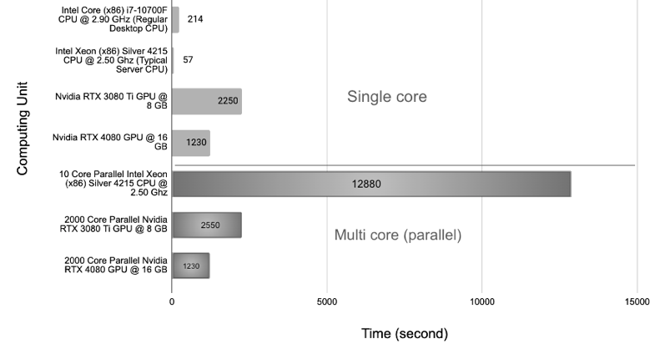
- Computational Speed of Different Resources for single and multi core (the lower the better)

DISCUSSION & CONCLUSION
GPU cores are generally less powerful than CPU cores, making CPUs better for single-sample simulations. However, GPU parallelization means the time to compute one sample is similar regardless of the number of samples. This differs from CPU calculations, where computation time increases linearly with the sample size. The results from both processing units were nearly identical, indicating that the GPU-based simulation is valid and promising for more efficient in-silico drug cardiotoxicity prediction.

References
[1] Jason Sanders and Edward Kandrot. 2010. CUDA by Example: An Introduction to General-Purpose GPU Programming (1st. ed.). Addison-Wesley Professional..
[2] T. O’Hara, L. Virág, A. Varró, and Y. Rudy, “Simulation of the Undiseased Human Cardiac Ventricular Action Potential: Model Formulation and Experimental Validation,” PLOS Comput. Biol., vol. 7, no. 5, p. e1002061, May 2011.
[3] R. L. Graham, G. M. Shipman, B. W. Barrett, R. H. Castain, G. Bosilca and A. Lumsdaine, "Open MPI: A High-Performance, Heterogeneous MPI," 2006 IEEE International Conference on Cluster Computing, Barcelona, Spain, 2006, pp. 1-9.

 *This research was partially supported by the Ministry of Food and Drug Safety (22213MFDS3922), the NRF (National Research Foundation of Korea) under the Basic Science Research Program (2022R1A2C2006326), and the MSIT (Ministry of Science and ICT), Korea, under the Grand Information Technology Research Center support program (IITP-2022-2020-0-01612) supervised by the IITP (Institute for Information & communications Technology Planning & Evaluation). Ki Moo Lim as the correspondence author is affiliated with Kumoh National Institute of Technology, Gumi, South Korea; email: kmlim@kumoh.ac.kr

